Data Flow Diagrams:

Project Design Phase-II

Data Flow Diagram & User Stories

|  |  |
| --- | --- |
| Date | 15th October 2022 |
| Team ID | PNT2022TMID37165 |
| Project Name | Project – Containment Zone Alerting Application |
| Maximum Marks | 4 Marks |

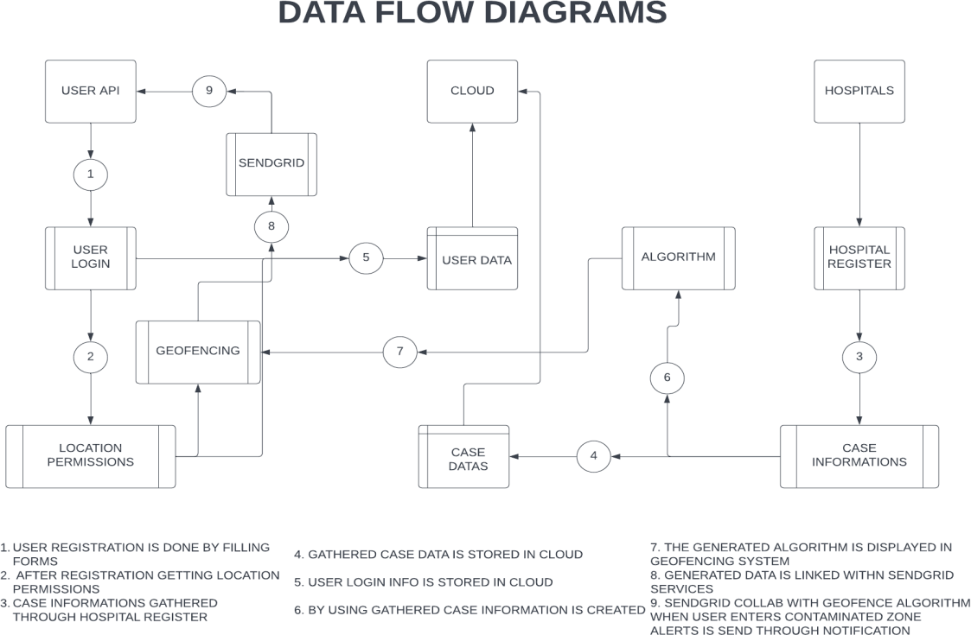

User Stories:

|  |  |  |  |  |  |  |
| --- | --- | --- | --- | --- | --- | --- |
| **User Type** | **Functional Requirement (Epic)** | **User Story Number** | **User Story / Task** | **Acceptance criteria** | **Priority** | **Release** |
| Customer (Mobile user) | Registration | USN-1 | As a user, I can register for the application  by entering my email, and password and confirming my password. | I can access my account/dashboard | High | Sprint-1 |
|  |  | USN-2 | As a user, I will receive a confirmation email once I have registered for the application. | I can receive a confirmation email & click confirm | High | Sprint-1 |
|  |  | USN-3 | As a user, I can register for the application through Facebook. | I can register & access the dashboard with Facebook Login | Low | Sprint-4 |
|  |  | USN-4 | As a user, I can register for the application through Gmail. | I can register & access  the dashboard with Google Login | Medium | Sprint-1 |
|  |  | USN-5 | As a user, I can register for the application through Twitter. | I can register & access the dashboard with Twitter Login | Low | Sprint 4 |
|  | Login | USN-6 | As a user, I can log into the application by entering my email & password | I can access it whenever I want its access. | High | Sprint-1 |
|  | Dashboard | USN-7 | As a user, I need to give permission to access My Contacts, Location, and  Storage. | I get access to their services | High | Sprint-2 |
|  |  | USN-8 | As a user, I get access to the dashboard which shows a map with marked zones | I can see the zone information on the dashboard. | high | Sprint-2 |

|  |  |  |  |  |  |  |
| --- | --- | --- | --- | --- | --- | --- |
| Administrator | Services | USN-9 | As an admin, I need to provide valid information about the pandemic out there. | I can get the pandemic updates out there. | high | Sprint-2 |
|  |  | USN-10 | As an admin, I need to provide medical advice through a chatbot. | I get medicinal recommendations through a chatbot. | medium | Sprint-3 |
|  |  | USN-11 | As an admin, I need to provide medical recommendations by collaborating with top hospitals. | I get medical instruction through chief doctors. | low | Sprint-3 |
|  |  | USN-12 | As an admin, I need to alert the user when they enter pandemic zones. | I got a notification when I am in the pandemic area. | Medium | Sprint-4 |
|  |  | USN-13 | As an admin, I need to provide preventive measures when they travel through it. | I got a remedies notification when I am in the pandemic area. | high | Sprint-3 |
|  |  | USN-14 | As an admin, I need to provide special services for premium users by giving services like monitoring health by their smart bands. | I was treated special after becoming a premium member. | low | Sprint 4 |
|  | Data collections | USN-15 | As an admin, I need to store all the user information on the cloud | I can access my information when I needed | Medium | Sprint-4 |

|  |  |  |  |  |  |  |
| --- | --- | --- | --- | --- | --- | --- |
|  |  | USN-19 | As an admin, I need to collect the list of viruses & bacteria present in this world. | - |  | Sprint-4 |